ATC Inspection procedure
for trailers of category O3, O4
Important Note: ATC inspections must be completely impartial and independent of any commercial activity associated with the trailer

The following ATC report is for inspection of category O3, O4 trailers
The full ATC report plus documents as in table below should be forwarded to NSAI. Photos of the inspected trailer (including a photo of the VIN as on the trailer) must also be forwarded. A copy of ATC report must also be given to applicant.
This document does not need to be completed electronically and may be completed by biro, scanned and returned.
All relevant sections should be signed and stamped by the ATC.

The following documents should be presented with the trailer for ATC inspection:

DOCUMENTS REQUIRED | Present | Not present
- Completed NSAI evaluation form
- Coupling manufacturers certificate and installation instructions for device
- Braking reports
- Rear under run, lateral rail and spray suppression documentation
- Any additionally technically relevant information e.g. drawings, weigh docket, other type approval certificates/test reports not mentioned above

DETAILS
Applicant Name:
VIN / Unique Identifier:
Category:
Trailer description (e.g. semi-trailer, drawbar, etc…)
Name of ATC:
Name of ATC tester:
ATC contact details | Ph: Email:
Location of ATC test:

Note to ATC inspector:
Below are the standard inspection items for trailer inspection. However, if there is any item for attention not included in standard inspection below, please state in remarks section and photograph observation. This may be poor or loose wiring (insecure or uninsulated), poor quality of construction or any element of the construction which may merit attention

ATC Inspection procedure for an O3 O4 trailer
enclose photographic evidence with report of each inspected area

3. Rear under run protection
Installation Check |  | Result
Width of the widest rear axle: |  | mm
Width of rear protective device: |  | mm
Difference: |  | mm
The width of the rear protective device is not less than the width of the widest rear axle by more than 100mm on either side (total 200mm).
The ground clearance: (must not exceed 550mm over its width) |  | mm
Securely attached to the vehicle chassis side members (Yes/No):
Vehicle Rear Construction Forms The Rear Protective Device
When the construction of the rear of the vehicle forms the rear under run protection device, then the ground clearance of the rear part of the vehicle must not exceed 550mm over a width which is not shorter than that of the rear axle by more than 100mm on either side (excluding any tyre bulging close to the ground). |  | mm
e / E Mark/ test report number:
4. Rear Registration plate space | Result (Pass/Fail)
- The space for mounting the rear registration plate shall comprise an even or virtually even rectangular surface with the following dimensions:  Width 520 with height 120mm  or Width 340 with height 240mm | Width  mm
Height:
mm
- The space must allow the mounting of a plate in a position as close to vertical as is possible by the vehicle structure available.
  - < 30º from the vertical if plate is facing upwards.
  - < 15º from the vertical if plate is facing downwards.
- The plate shall be visible in the whole space (Yes/No).
- Height of lower edge of plate from the ground (>0.3m) | mm
- Height of upper edge of plate from the ground (<1.2m) | mm
- Located centrally or left of center but within left outer edge | Y: | N:

18. Plates and identification (submit photos of plate and engraved identifier on chassis) | Result Present Yes/No
Statutory plate contains: | Yes | No
Name of manufacturer:
Type-approval number (if available at time of inspection):
Vehicle Identification Number (VIN) or Unique Identifier:
Maximum permitted laden mass of the trailer:
Maximum permitted road mass for each axle, listed in order from front to rear (including king pin/coupling device):
Maximum permitted mass on axle group identified by “T”:
VIN or unique identifier is marked on chassis or other structure on right hand side in such a way that it cannot be obliterated or deteriorate:
The height of the characters shall not be less than 4 mm.

46. Tyres (Note - see appendix 2 below) | Result
- is fitted with e or E marked tyres (record approval number and the axle number its fitted on) | E number:
- are marked with the appropriate speed and load ratings for their particular axle locations and the intended use of the vehicle. (see appendix 2 below for indices) | Speed rating:  Load rating:
- Each tyre fitted must have the same structure (eg bias-belted, crossply or radial), nominal size and aspect ratio as any other tyre on the same axle

5. Steering (if applicable)
See appendix 3 below for definitions
Test area requirements:
The tests outlined below must be performed in a flat open area test site, marked out accordingly with minimum dimension of 65m x 65m to allow manoeuvrability tests.
Video evidence of test required
 | Yes | No
Are any of the axles steered axles?
If Yes, complete below
Number of steered axles (foremost axle is No1, next is 2 and so on): | Axle No(s):
 | Yes | No
Type of steering:
Self-tracking steering equipment:
Articulated steering:
Self-steering:
Type of steering:
Purely mechanical steering transmission:
Purely hydraulic steering transmission:
Purely electric steering transmission:
Requirement | Result
- (1)The steering system shall ensure easy and safe handling of the vehicle
- (2)The trailer must travel without excessive deviation or unusual vibration in its steering equipment when the towing vehicle is travelling in a straight line on a flat and horizontal road
- (3)With the towing vehicle and trailer having adopted a steady state turn corresponding to a turning circle radius of 25 m (see definition below appendix 3) at a constant speed of 5 km/h, the circle described by the rearmost outer edge of the trailer shall be measured. This manoeuvre shall be repeated under the same conditions but at a speed of 25 km/h ± 1 km/h. During these manoeuvres, the rearmost outer edge of the trailer travelling at a speed of 25 km/h ± 1 km/h shall not move outside the circle described at a constant speed of 5 km/h by more than 0.7 m.
See figure 2 below
- (4)No part of the trailer shall move more than 0.5 m beyond the tangent to a circle with a radius of 25 m when towed by a vehicle leaving the circular path described in paragraph item 3 above. along the tangent and travelling at a speed of 25 km/h.
See figure 3 below

Illustration of steering test requirements above items (3) and (4)

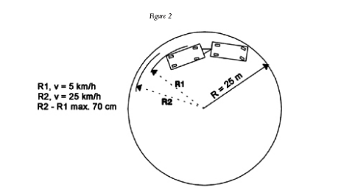

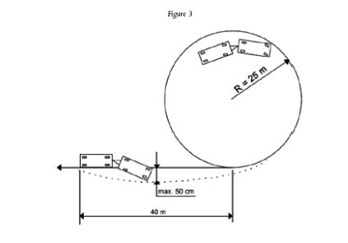

48. Masses and dimensions
See appendix 4 below for definitions
Overall Dimensions
Length (mm) | Width (mm) |  | Height (mm)
Axle Track (mm)
Axle 1: |  | Axle 2: | Axle 3:
Axle 4: |  | Axle 5: | Axle 6:
Axle spacing (1st to 2nd, 2nd to 3rd, etc):  extend table accordingly if more than 3 axles |  |  | 1-2 | mm
 |  |  | 2-3 | mm
Wheelbase (mm):  For semi-trailer distance from centre of coupling pin to 1st axle  For 2 or 3 axle drawbar trailer – distance from coupling point to 1st axle |  |  | mm
Rear overhang (mm):  (centre of rearmost axle to rearmost point of trailer) |  |  | mm
Front Overhang (see Appendix 4 below for description): |  |  | mm
Max front fitting radius (semi-trailer only) :  Cannot exceed 2.04m. (see Appendix 4 below for description): |  |  | mm
Length of loading area (mm): |  |  | mm
Are any of the axles lift axles? If yes, what number axle?:
(Axle 1 being foremost axle)
Manoeuvrability requirements
Semi-trailers may comply with the drive test method or calculation method below
Drive test method
Any trailer must be able to manoeuvre on either side for a complete circular trajectory of 360° inside an area defined by two concentric circles, the outer circle having a radius of 12,50 m and the inner circle having a radius of 5.30 m, without any of the vehicle's outermost points (with the exception of the protruding parts prescribed for the vehicle width in appendix 4 below ) projecting outside the circumferences of the circles .
For semi-trailers with axle-lift device (see axle-lift definition appendix 4 below) this requirement also applies with the axle(s ) in the lifted position (within the meaning of axle lift definition ).

Calculation method
A semi-trailer is deemed to comply with the requirements of above if its wheelbase is not
greater than:
$$\sqrt{{(12.50-2.04)}^{2}-{(5.30+\frac{L}{2})}^{2}}$$
where L is the semi-trailer's width
 |  |  |  |  | Yes | No
Manoeuvrability requirements met by drive test method above:
If yes, submit video of test with this report
Manoeuvrability requirements met by calculation method above:
If yes, submit calculations with this report
50. Couplings
EC approval number of coupling device:

Class of coupling device:

D-value:

S-value:

Attachment of Drawbar Eyes and Drawbars on Trailers
Requirement | Observation and Result
- Drawbars for centre-axle trailers must have a  support device adjustable in height if the vertical  bearing load at the drawbar eye on the trailer type  exceeds 50 kg, when the trailer is uniformly loaded to its technically permissible maximum mass: | Vertical load on drawbar eye: kg  (S-value)  If greater than 50kg, adjustable  support device fitted: Yes No
- When attaching drawbar eyes and drawbars to  centre-axle trailers with a maximum mass of more than 3.5 tonnes and more than one axle, must be equipped with a device for axle load sharing: | Maximum mass of  centre-axle trailer: tonnes  If greater than 3.5 tonnes, axle  load sharing device fitted: Yes No
Attachment of Mounting Plates and Coupling Pins on trailers
Requirements | Observation and Result
Semi-trailers must be equipped with landing gear or any other equipment which allows uncoupling and parking of the semi-trailer:  If semi-trailers are equipped so that the connection of the coupling devices, the electrical systems and braking systems can be effected automatically, the trailer must have landing gear which retracts from  the ground automatically after the semi-trailer has been coupled up: | Semi-trailer fitted with  landing gear: Yes No  If not, is it fitted with any  other equipment which allows  uncoupling and parking of  the semi-trailer: Yes No  If yes, brief description of this equipment:  _________________________________________  Yes No
The fixing of the fifth wheel coupling pin in the mounting plate on the semi-trailer must be as instructed by the vehicle manufacturer or manufacturer of the fifth wheel coupling: | Yes No
Is semi-trailer equipped with a steering wedge:  -Dimensions of steering wedge:  - The steering wedge must allow safe and secure  coupling-up:  - The steering wedge must be spring-mounted:  - The strength of the spring must be selected so that  it is possible to couple up an unloaded semi-trailer  and so that, with the semi-trailer fully loaded, the  steering wedge is firmly in contact with the flanks  of the coupling during travel:  - Uncoupling of the fifth wheel must be possible  with the semi-trailer both loaded and unloaded: | Yes No  Thickness: mm  Length: mm  Width at both ends: mm  mm  Yes No  Yes No  Yes No  Yes No

The following reports must be completed also and submitted with rest of inspection. Contact NSAI if your ATC requires a copy of these report to complete tests:

9. Brakes –TR009
Please contact NSAI if need copy of this report forwarded | Attached (Yes/No)
Report TR009 to be completed by the ATC and attached

42. Lateral Protection – TR-042
Please contact NSAI if need copy of this report forwarded | Attached (Yes/No)
Report TR042 to be completed by the ATC and attached

43. Spray suppression – TR043
Please contact NSAI if need copy of this report forwarded | Attached (Yes/No)
Report TR043 to be completed by the ATC and attached

20. Installation of lighting and light signalling devices –TR-020-O
Please contact NSAI if need copy of this report forwarded | Attached (Yes/No)
Report TR020 - O to be completed by the ATC and attached

Equipment and calibration data for all tests/inspections carried out:

Equipment name | Serial number | Calibration due date | Test record No

Remarks:

5. Signature and Authorisation of ATC

I confirm that I have carried out all relevant inspections as per this inspection report in accordance with the test procedures for this category of vehicle and category of approval.

Vehicle Identification Number /unique identifier(VIN):___________________________________________________________

Signature Date
----------------------- -----------------------
Name official stamp of ATC]

Appendix 1
 | Colour | Presence | Number | Arrangement | Position* | Geometric Visibility  ß=horizontal angle  α= vertical angle | Electrical Connections | Tell-Tale
Reversing Lamp | White | Mandatory  O2, O3,O4,  optional on O1 trailers  Category AR | 1 mandatory 2nd optional | No individual specification | Width - no requirement  Height -above 250 – below  1200 mm | α =15° upwards and 5° downwards  ß=45° to right and left if one device.  30°if two installed | Only light when in reverse | Optional
Direction Indicators | Amber | Mandatory  Category 2a or 2b | 2 | 2 rear | W: < 400mm from edge H: 350-1500mm  (2100mm if 1500mm not possible) | α = 15° upwards and downwards  ß=80° outwards and 45° inwards | See R-48 | Visible or auditory or both
Hazard Warning | Amber | Mandatory | 2 | 2 rear | See direction indicators above | See direction indicators above | See R-48 | Circuit closed tell-tale see R-48
Stop Lamp | Red | Mandatory  Category S1 or S2 | 2 | no special arrangements | Width-inner edges not less than 600mm apart. 400mm if overall width trailer less 1300mm  H: 350-1500mm  (2100mm if 1500mm not possible) | α = 15° upwards and downwards  ß=45° to right and left | Must light up when brake applied | Optional, see R-48
Rear Registration Plate Lamp | White | Mandatory  Category L | Such that the device illuminates the plate | Such that the device illuminates the plate | Such that the device illuminates the plate | Such that the device illuminates the plate | See R-48 | Optional
Front Position Lamp | White | Mandatory on trailers if  > 1600mm wide  Category A | 2 | no special arrangements | W: < 150mm from edge H: 350-2100mm | α = 15° upwards and downwards  ß=80° outwards and 45° inwards | See R-48 | Circuit closed tell-tale
Rear Position Lamp | Red | Mandatory  Category RorR1orR2 | 2,  see R-48 | no special arrangements | W: <400mm H: 350-1500mm  (2100mm if 1500mm not possible) | α = 15° upwards and downwards  ß=80° outwards and 45° inwards | See R-48 | Circuit closed tell-tale see R-48

 | Colour | Presence | Number | Arrangement | Position* | Geometric Visibility  ß=horizontal angle  α= vertical angle | Electrical Connections | Tell-Tale
Rear Fog Lamp | Red | Mandatory  Category  F or F1 or F2 | 1 or 2 | no special arrangements | See R-48  H: 250-1000mm | α = 5° upwards and downwards  ß=25° right and left | See R-48 | Circuit closed tell-tale
End-Outline Marker Lamp | White Front, Red Rear | Mandatory if width >2.1m  Category  A or AM (front)  R,R1,R2,RM1orRM2 (Rear) | 2 front, 2 rear | no special arrangements | W: < 400mm and as close as possible to edge  H: at max. height compatible with design | α = 15° above and below  ß=30° inwards and outwards | See R-48 | Optional, see R-48
Rear Retro-Reflector Triangular | Red | Mandatory Category class IIIA or IIIB | 2 | Apex of ▲ directed upwards | W: < 400mm  H:250-900 or 1200 or 1500  See R-48 | α = 15° above and below  ß=30° inwards and outwards | n/a | n/a
Front Retro-Reflector Non-Triangular | White | Mandatory Category class IA or IB | 2 | No special arrangements | W < 150mm H: 250-900mm  (1500mm if 900mm not possible) | α = 10° above and below  ß=30° inwards and outwards | n/a | n/a
Side Retro-Reflector Non-Triangular | Amber | Mandatory Category class IA or IB | See R-48 | No special arrangements | H: 250-900mm(1500mm if 900mm not possible)  L: fitted middle third and distance between adjacent reflectors <3m.See R-48 | α = 10° above and below  ß=45° front and to the rear | n/a | n/a
Side-Marker Lamps | Amber | Mandatory if: > 6m long,  Category SM1 | See R-48 | No special arrangements | H: 250-900mm(1500mm if 900mm not possible)  L: fitted middle third and distance between adjacent reflectors <3m.See R-48 | α = 10° above and below  ß=45° front and to the rear | See R-48 | See R-48
Conspicuity Markings | white/yellow side, red/yellow rear | Mandatory if:>2100mm width O3, O4  Full contour markings rear  >6mlong partial contour to side | See R-48 | See R-48 | See R-48 | See R-48 | n/a | n/a

* Note: width indicates distance from external edge of trailer to nearest edge of illuminated area; height indicates distance from ground to lower edge of illuminated area

Appendix 2
Load capacity index

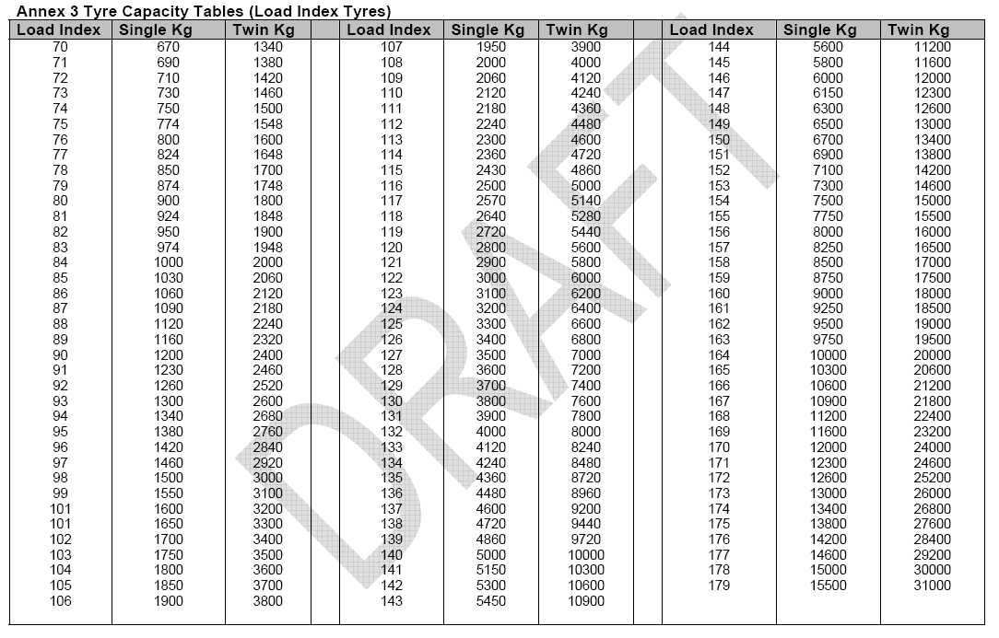

Appendix 2
Speed category symbol

Speed category symbol | Corresponding speed
F | 80
G | 90
J | 100
K | 110
L | 120
M | 130
N | 140
P | 150
Q | 160
R | 170
S | 180
T | 190
U | 200
H | 210
V | 240

Appendix 3

Steering definitions and explanatory notes:

"Self-tracking steering equipment" means a system designed to create a change of
steering angle on one or more wheels only when acted upon by forces and/or
moments applied through the tyre to road contact

"Articulated steering" means equipment in which the steering forces are produced by a change in direction of the towing vehicle and in which the movement of the steered trailer wheels is firmly linked to the relative angle between the longitudinal axis of the towing vehicle and that of the trailer

“Self-steering" means equipment in which the steering forces are produced by a change in direction of the towing vehicle and in which the movement of the steered trailer wheels is firmly linked to the relative angle between the longitudinal axis of the trailer frame or a load replacing it and the longitudinal axis of the sub-frame to which the axle(s) is (are) attached

"Purely mechanical steering transmission" means a steering transmission in which
the steering forces are transmitted entirely by mechanical means.

"Purely hydraulic steering transmission" means a steering transmission in which the
steering forces, somewhere in the transmission, are transmitted only by hydraulic
means.

"Purely electric steering transmission" means a steering transmission in which the
steering forces, somewhere in the transmission, are transmitted only through electric
means

"Turning circle" means the circle within which are located the projections onto the
ground plane of all the points of the vehicle, excluding the external mirrors and the
front direction indicators, when the vehicle is driven in a circle;

Appendix 4

Masses and Dimension definitions and explanatory notes:

‘Axle-lift device' means a device permanently fitted to a vehicle for the purpose of
reducing or increasing the load on the axle(s), according to the loading conditions of the
vehicle :
— either by raising the wheels clear off the ground/lowering them to the ground,
— or without raising the wheels off the ground, (e.g. in the case of air suspension
systems, or other systems ),
in order to reduce the wear on the tyres when the vehicle is not fully laden, and/or make
starting (moving off) on slippery ground easier

List of items NOT included in overall length measurement:

- Wiper and washer devices,
- Front or rear marking plates,
- Customs sealing devices and their protection,
- Devices for securing the tarpaulin and their protection,
- Lighting equipment,
- Mirrors and other devices for indirect vision,
- Watching aids,
- Air-intake pipes,
- Length stops for demountable bodies,
- Access steps and hand-holds,
- Ram rubbers and similar equipment,
- Lifting platforms, access ramps and similar equipment in running order, not exceeding 300 mm, provided that the loading capacity of the vehicle is not increased,
- coupling devices for motor vehicles,
- Trolley booms of electrically-propelled vehicles,
- External sun visors.

List of items NOT included in overall width measurement:

- Customs sealing devices and their protection,
- Devices for securing the tarpaulin and their protection,
- Tyre failure tell-tale devices,
- Protruding flexible parts of a spray-suppression system
- Lighting equipment,
- Mirrors and other devices for indirect vision,
- Tyre-pressure indicators,
- Retractable steps,
- The deflected part of the tyre walls immediately above the point of contact with the ground,

Rear Overhang:
The rear overhang of a vehicle should be measured from the centre of the rearmost axle to the rear most point of the vehicle. See figure 1 below.
Note: The list above in relation to items not considered for overall length does not apply to this measurement. The rearmost point regardless of what it is must be considered.

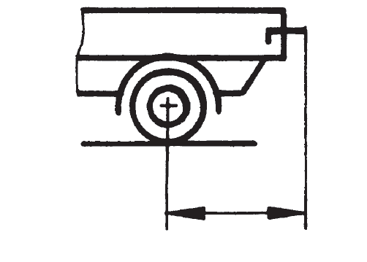
Figure 1

Axle Track:
Axle track is the distance from the centre of the wheel on one side to the centre of the wheel on the other side for single wheel axles. For axles with double wheels, it is the distance from the centre of the gap between the two wheels on one side to the centre of the gap between the two wheels on the other side. This is shown in the figure 2. The easiest way to measure this in any case is from the outside of the outmost wheel on one side to the inside of the innermost wheel on the other side.

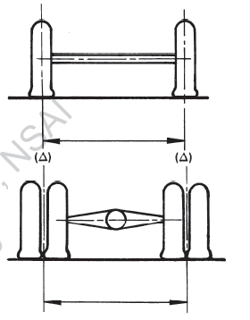

Figure 2

Front overhang:
front overhang’ means the horizontal distance between the vertical plane passing through the first axle or the kingpin axle in the case of a semi-trailer and the foremost point of the vehicle;

Front Fitting Radius:

‘front fitting radius of semi-trailer’ means the horizontal distance from the axis of the kingpin to any point at the front of the semi-trailer. This cannot exceed 2.04m to any forward points of the semi-trailer kingpin (see illustration below)

If not available at time of inspection, can be forwarded to NSAI prior to final approval so long as it does not prevent the ATC from carrying out relevant inspection
However, where it is impossible in practice to comply with this provision, the height may exceed 1.20 m but no case exceed 2 m
the wheelbase being measured for the purpose of this section as the distance of the axis of the semi-trailer fifth wheel king-pin to the centre line of the non-steering bogie axles; if one or more of the non-steering bogie axles has an axle lift device (see 2.14 ), then the wheelbase with lowered/lifted axle(s ), whichever is the longer, is taken into account.

